**LOGGING IN SPRINGBOOT**

SPRINGBOOT

LOGGING

In springboot in order to do logging we will use the loggingfactory which has a static method which will take asinput the class in which we want to apply the logging.

The way spring does logging is depending on below

By default the spring boot application sllaows the info logs to be printed the others are not so if we ant our logging.trace to be printed then we need to do the following:

In our application .properties file

We can also specify that we want info level logs for the root level but only one package we want tehtarce level logs

**ELK**

**Elastic search logstasha dn kibana**

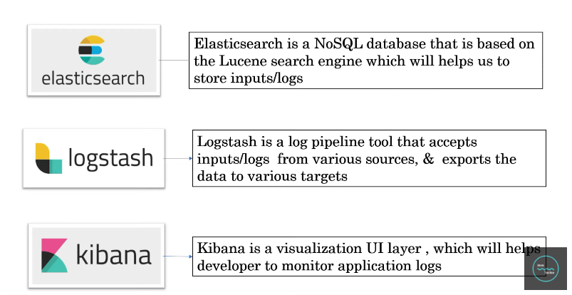

**CENTRALIZED LOGGING**